Task on IAM
1. Create one IAM user and assign EC2 and S3 full access roles.
Step 1: Open IAM
- Sign in to the AWS Management Console.
- Search for IAM in the search bar.
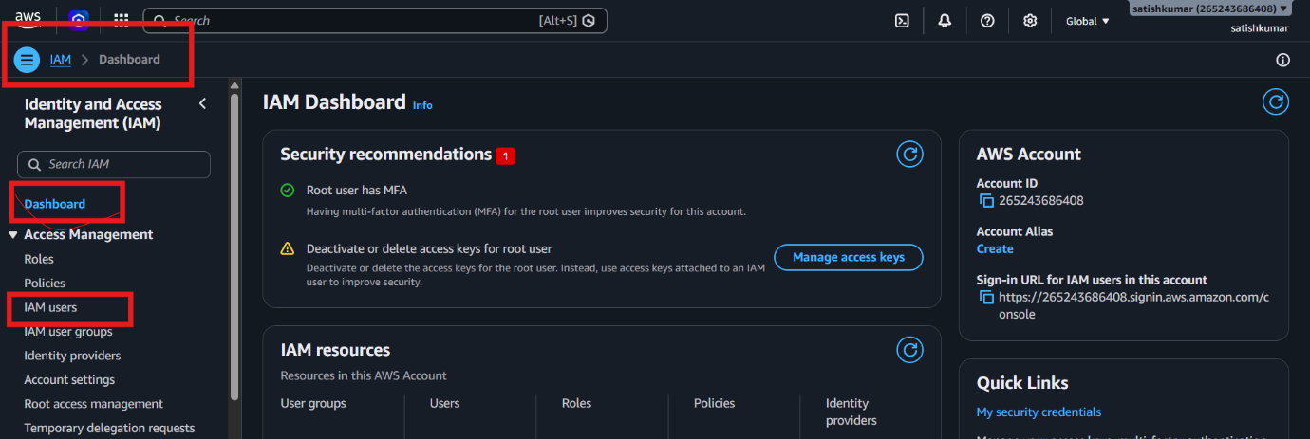
- Click IAM.
Explanation:
IAM (Identity and Access Management) is used to create users, groups, roles, and manage permissions in AWS.

Step 2: Create a New IAM User
- In the left menu, click Users.
- Click Create user.
- Enter a username (Example: ec2-s3-user).
- Click Next.
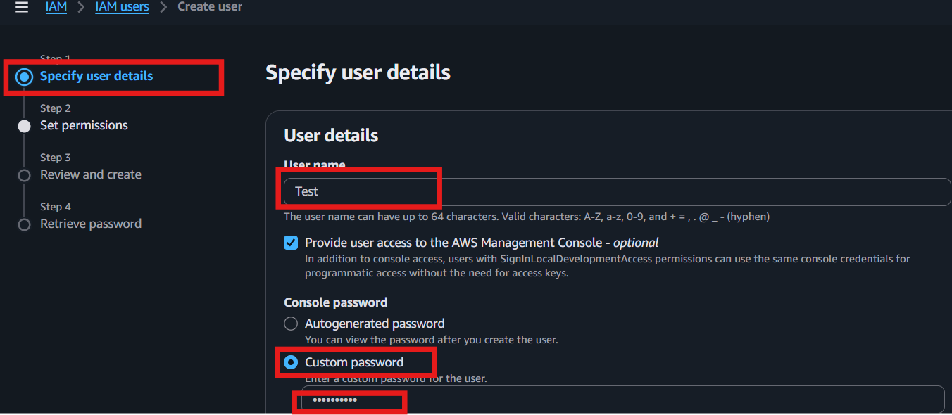

Explanation:
An IAM user represents a person or application that needs access to AWS resources.

Step 3: Assign Permissions
- Select Attach policies directly.
- In the search box, type AmazonEC2FullAccess.
- Select AmazonEC2FullAccess.
- Search for AmazonS3FullAccess.
- Select AmazonS3FullAccess.
- Click Next.
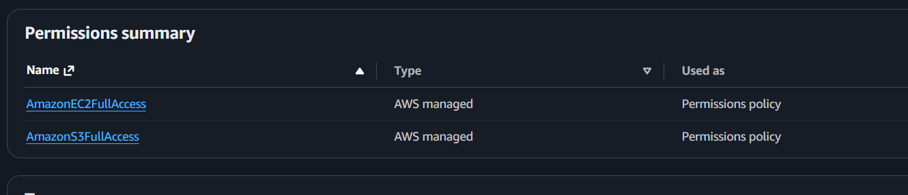
Explanation:
- Policies are permission documents that define what actions a user can perform.
- AmazonEC2FullAccess allows the user to create, start, stop, terminate, and manage EC2 instances.
- AmazonS3FullAccess allows the user to create, delete, upload, download, and manage S3 buckets and objects.

Step 4: Review and Create the User
- Review the username and attached policies.
- Click Create user.
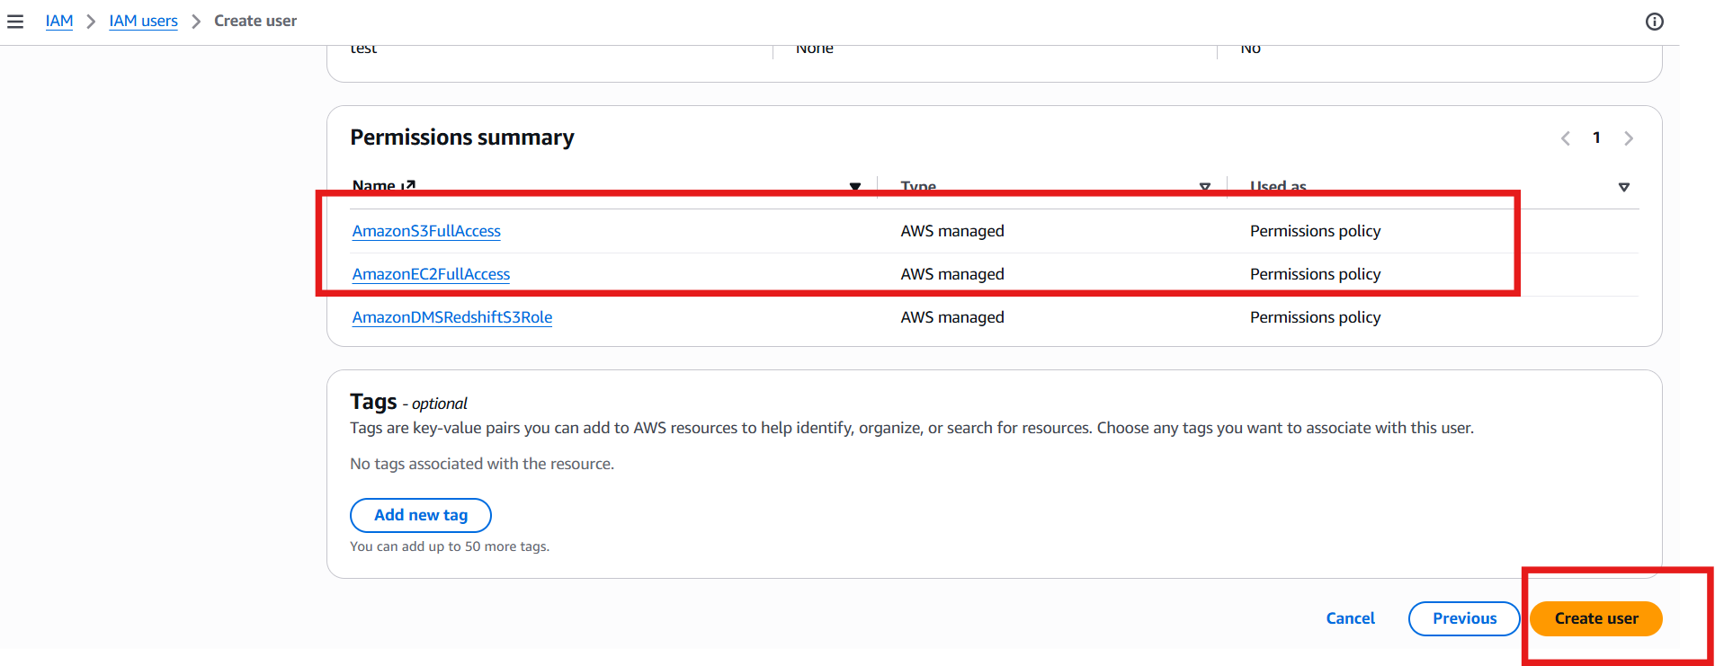
Explanation:
AWS creates the IAM user with the selected permissions.

Step 5: Enable AWS Console Access
If the user needs to log in to the AWS Console:
- Open the newly created user.
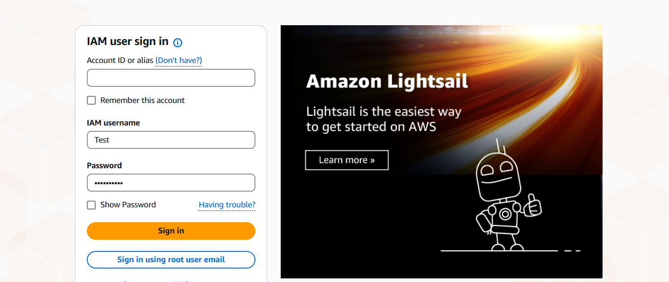
- Try to login to IAM user
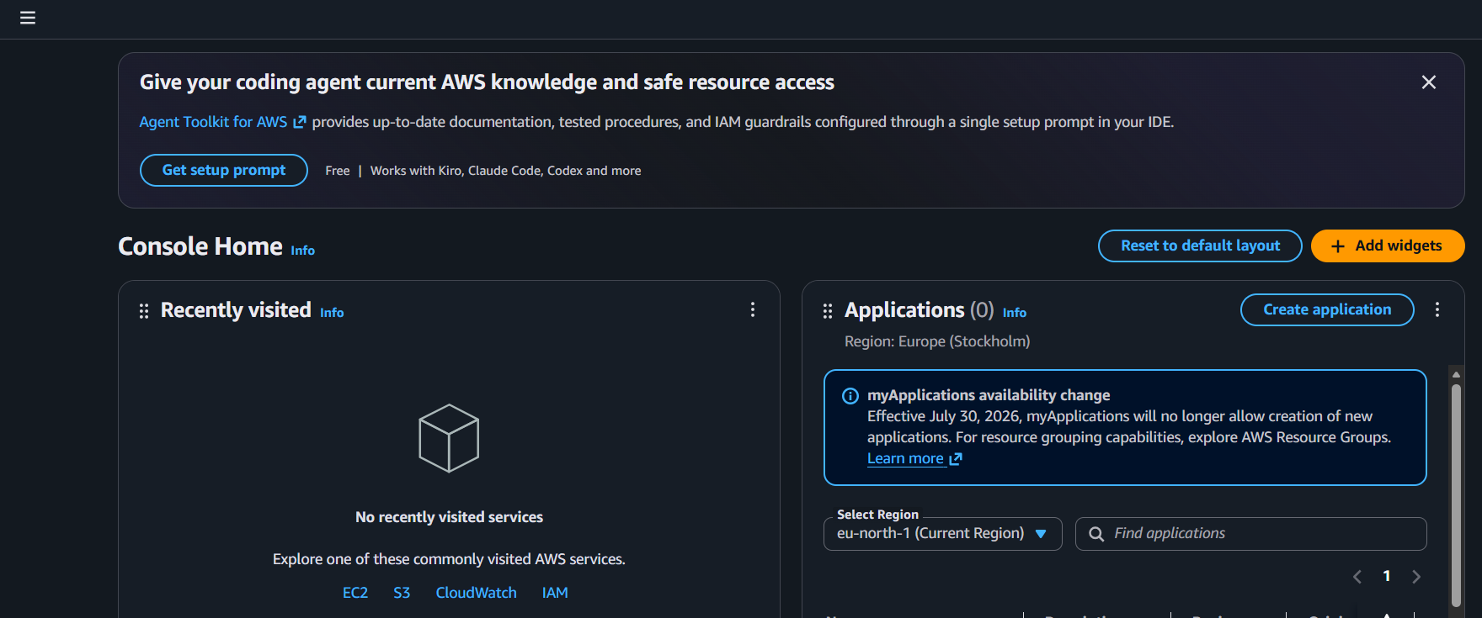

Step 3: Create s3 bucket
- In IAM user try to create S3
- click in s3
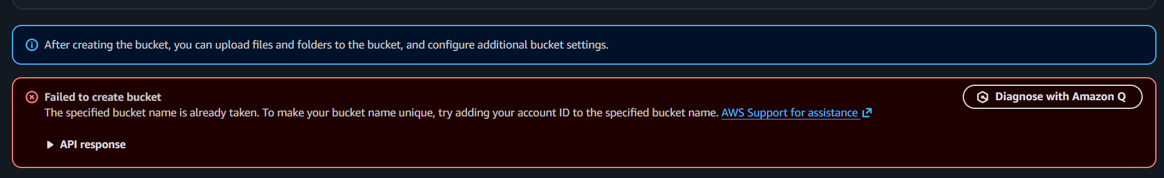
Error: this IAM user does not have access to create s3 bucket
Step 4: Go to root user and create S3 bucket
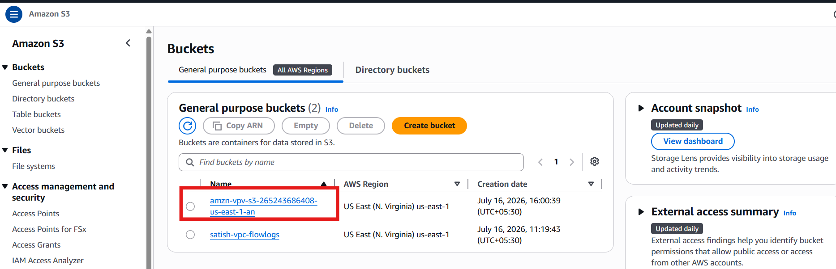

Step 5. Now check in IAM user we can see s3 bucket.
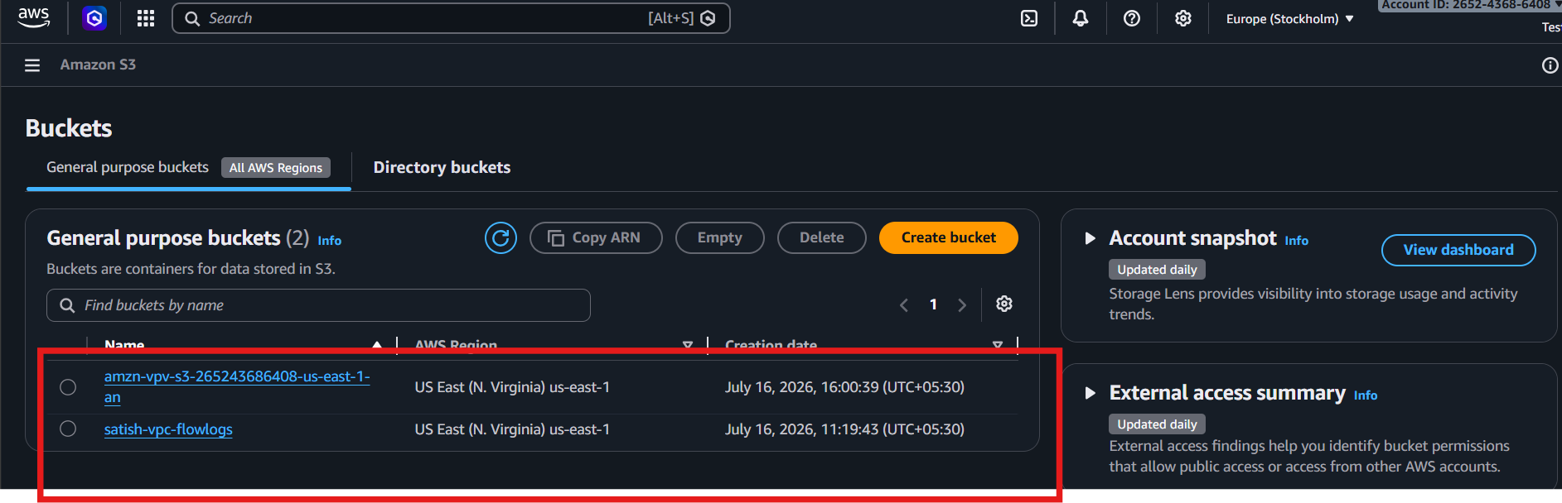

Case: After assigning the AmazonS3FullAccess policy to the IAM user, the user can successfully create and manage Amazon S3 buckets using their IAM credentials.
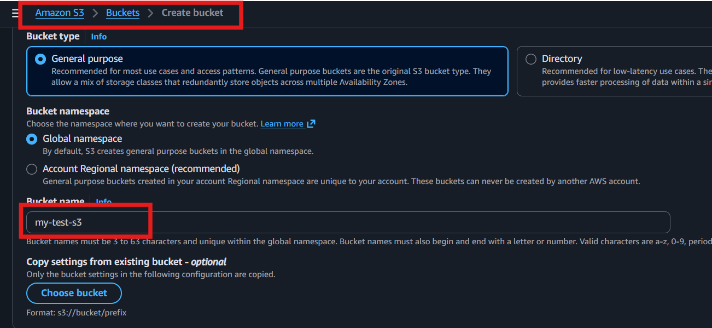
IAM user and successfully created an Amazon S3 bucket, confirming that the AmazonS3FullAccess policy was applied correctly.
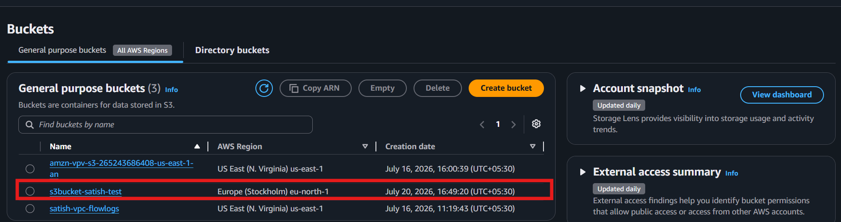

2. Create one group in IAM and assign read access for EC2.

Step 1: Open IAM
- Go to AWS Management Console → IAM.
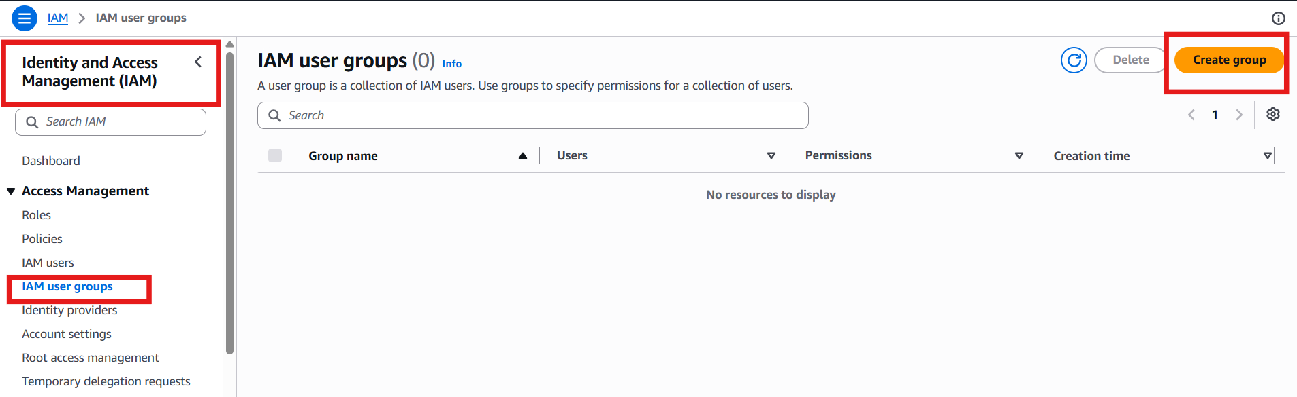

Step 2: Create a Group
- Click User groups → Create group.
- Enter a group name
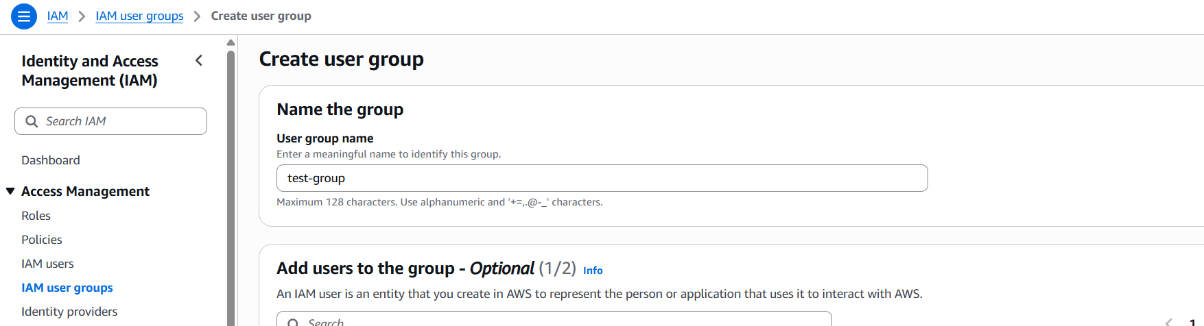

Step 3: Attach Permission
- Under Attach permissions policies, search for AmazonEC2ReadOnlyAccess.
- Select the policy.
- Click Create group.
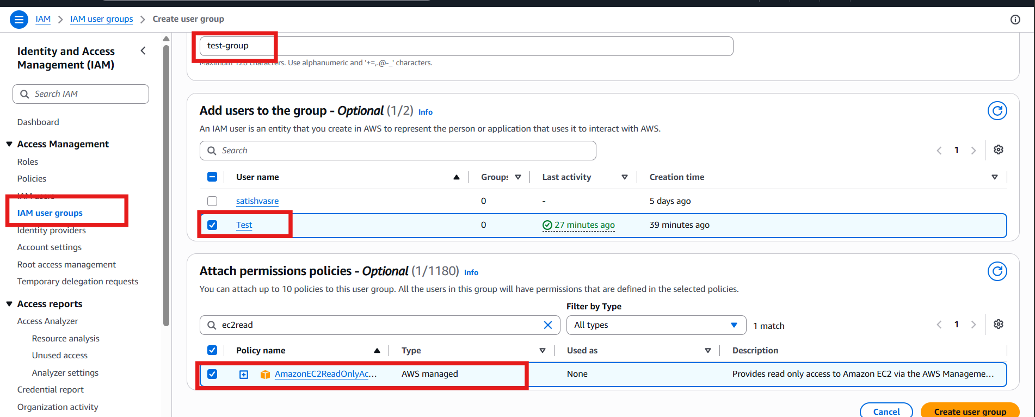
AmazonEC2ReadOnlyAccess allows users to view EC2 resources but does not allow creating, modifying, or deleting them.

Step 4: Add User to the Group
- Open the created group.
- Click Add users.
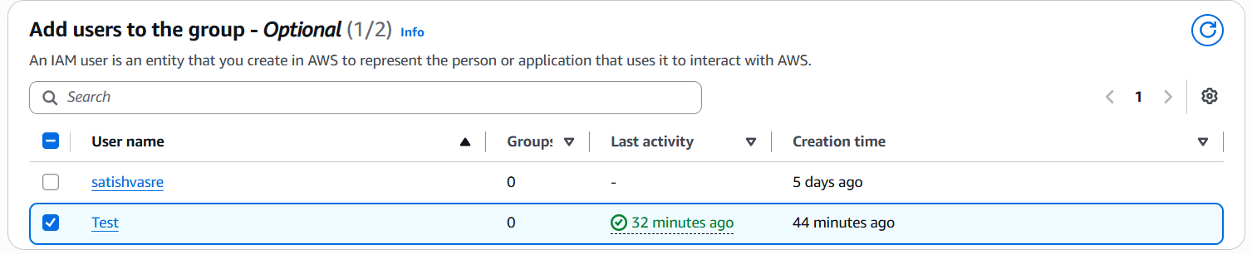

Result
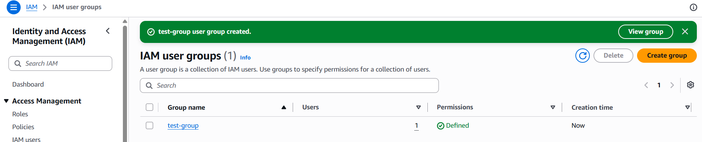
The IAM user is now a member of the group and has read-only access to Amazon EC2.

3. Create a new user named "Devops" and add to the group created in task 2.

Step 2: Create a New User
- Click Users → Create user.
- Enter the username Devops.
- Click Next.
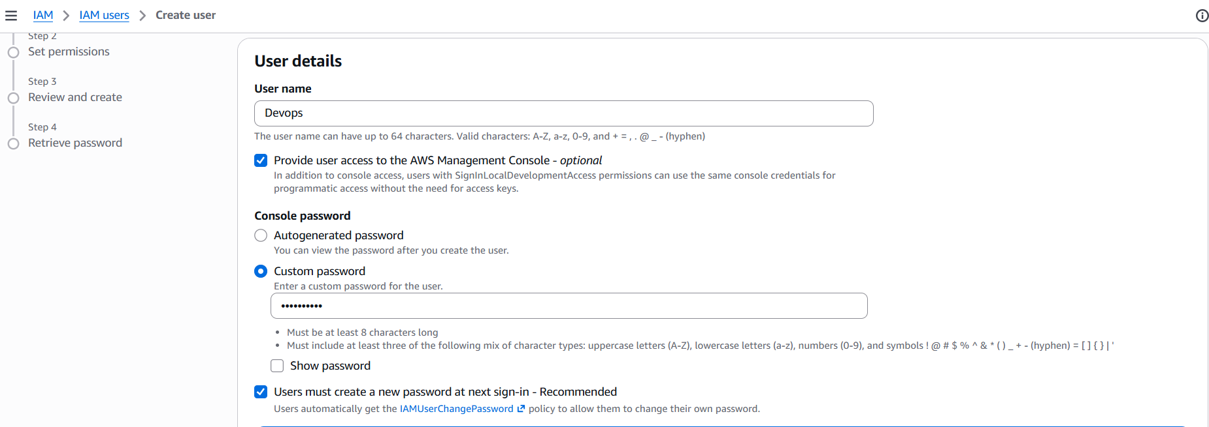

Step 3: Add User to Existing Group
- Select Add user to group.
- Choose the group created in Task 2 (e.g., EC2-ReadOnly-Group).
- Click Next.
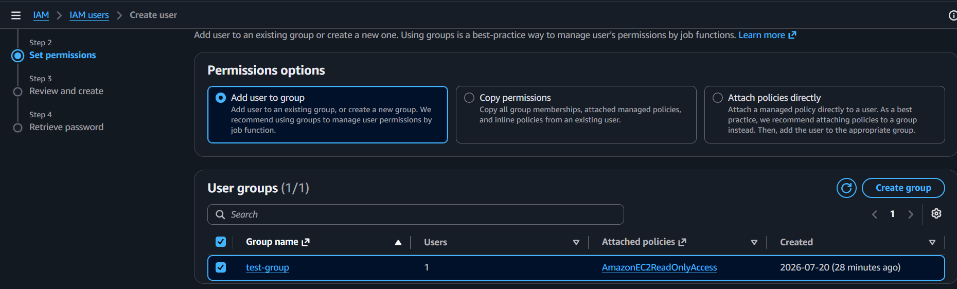
Adding the user to the group automatically grants the group's permissions (AmazonEC2ReadOnlyAccess).

Step 4: Review and Create
- Review the details.
- Click Create user.
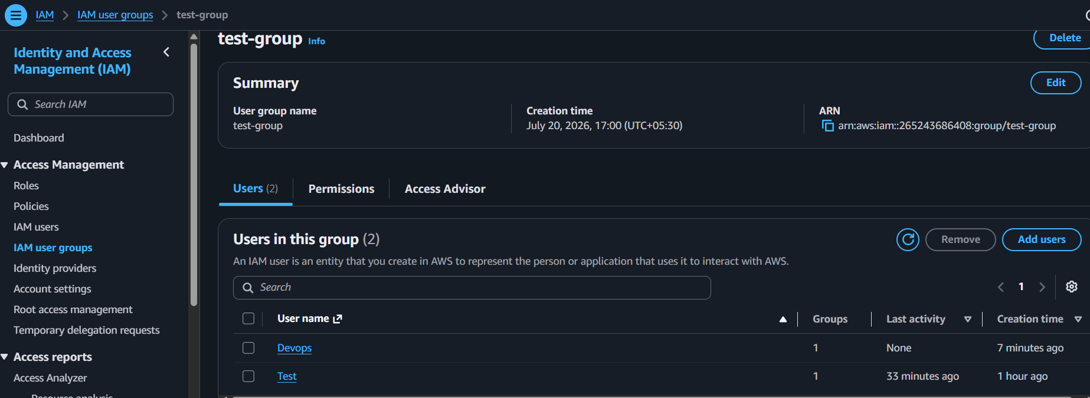

Result
The Devops IAM user is created and inherits EC2 Read-Only permissions from the IAM group.
4. Write a bash script to create an IAM user with VPC full access.
Prerequisites
Before starting, make sure:
- ✅ You are connected to your EC2 instance.
- ✅ AWS CLI is installed.
- ✅ AWS CLI is configured with an IAM user that has IAM permissions.

Step 1: Verify AWS CLI
Run:
aws --version
Expected output:
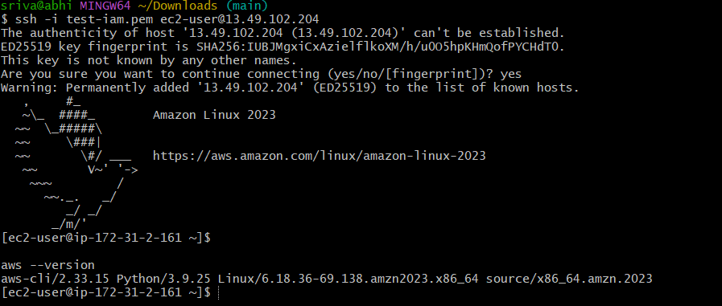
aws-cli/2.x.x

Step 2: Verify AWS Credentials
Run: aws sts get-caller-identit
If you get an error, configure AWS CLI:

aws configure
Enter:
AWS Access Key ID:
AWS Secret Access Key:
Default region name: us-east-1
Default output format: json 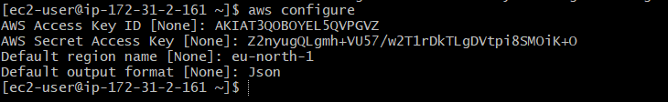

Step 3: Create a Bash Script
Create a new file:
vi create-vpc-user.sh 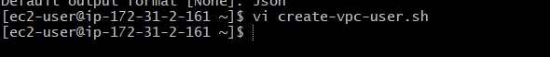

Step 4: Enter Insert Mode
Press: i
Now paste the following script: 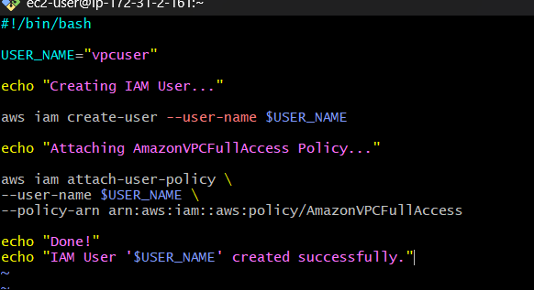
:wq!

Step 6: Give Execute Permission
Run:
chmod +x create-vpc-user.sh
Verify:
ls -l
Expected: 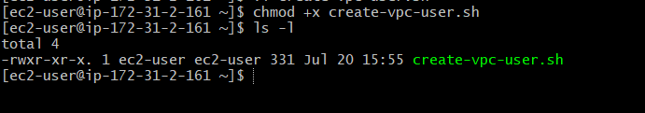

Step 7: Run the Script
Execute:
./create-vpc-user.sh
Expected output: 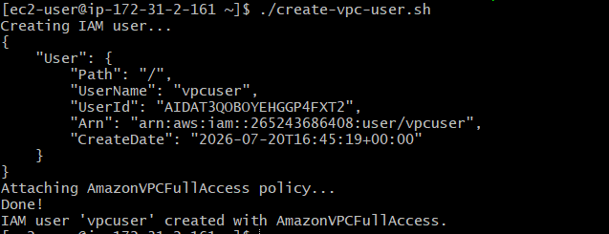
IAM User 'vpcuser' created successfully.

Step 8: Verify the User
Check if the user was created:
aws iam get-user --user-name vpcuser
Expected: 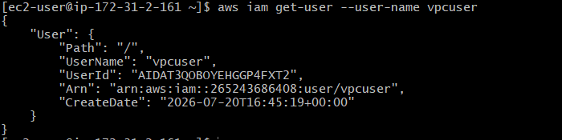

Step 9: Verify the Attached Policy
Run:
aws iam list-attached-user-policies --user-name vpcuser
Expected output: 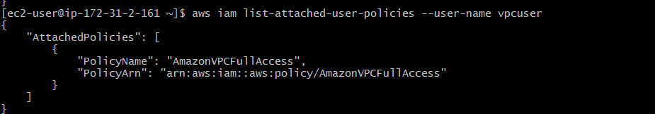

5. Create an IAM policy to allow EC2 access for a specific user in specific regions only.
Step 1: Create a policy file.
vi ec2-region-policy.json
Step 2: Press i and paste: 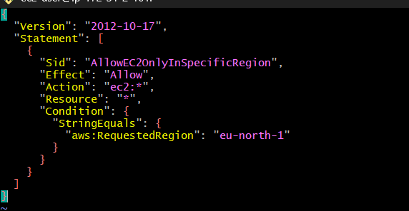
Save: Esc → :wq

Step 3: Create the IAM policy.
aws iam create-policy \
--policy-name EC2SpecificRegionPolicy \
--policy-document file://ec2-region-policy.json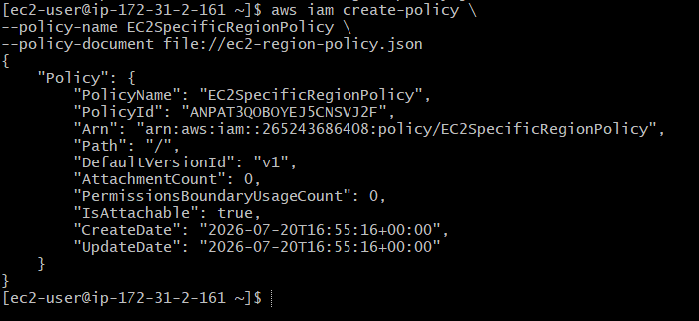

Step 4: Attach the policy to the user.
aws iam attach-user-policy \
--user-name Devops01 \
--policy-arn arn:aws:iam::265243686408:policy/EC2SpecificRegionPolicy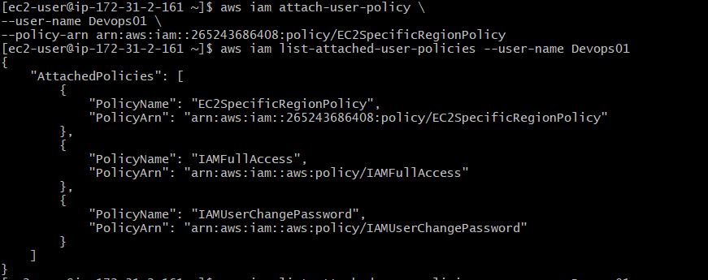

Step 5: Verify.
aws iam list-attached-user-policies --user-name Devops01
Expected: EC2SpecificRegionPolicy is attached. ✅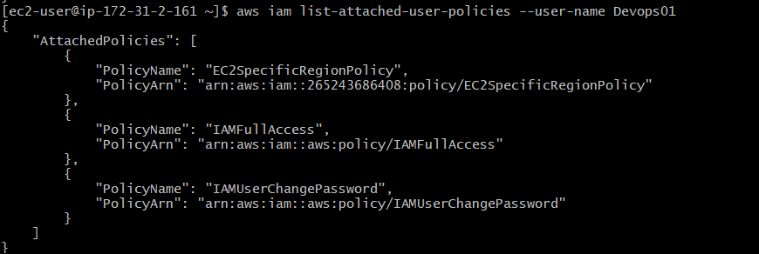

6. We have two accounts: Account A and Account B. Account A user should access an S3 bucket in Account B.
(Collaborate with a team member and execute this. This is mostly asked in every interview.)
Account A (Your AWS Account)
Step 1: Create an IAM User
- IAM → Users → Create User
- User name: Devops01
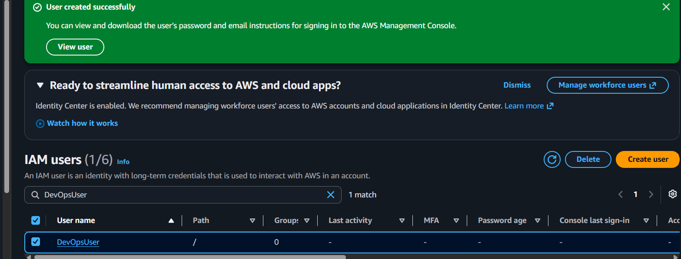

Step 2: Attach an IAM Policy
Go to:
IAM → Users → Devops01 → Add Permissions → Create Inline Policy → JSON
- FRIEND_BUCKET_NAME → Your friend's bucket name.
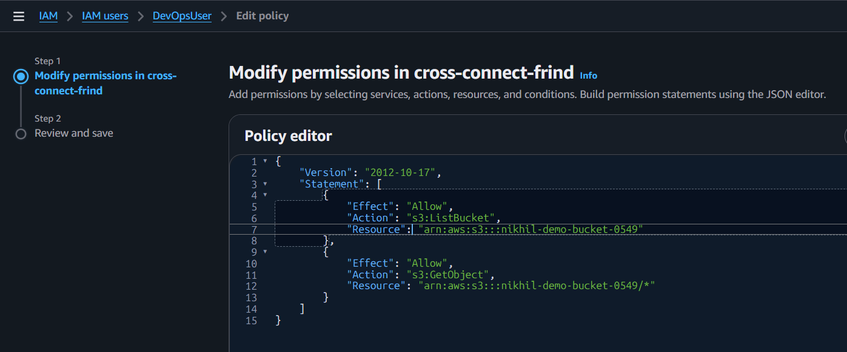

Step 3: Share Details with Your Friend
Send your friend:
- Your AWS Account ID (12 digits)
- Your IAM Username (Devops01)
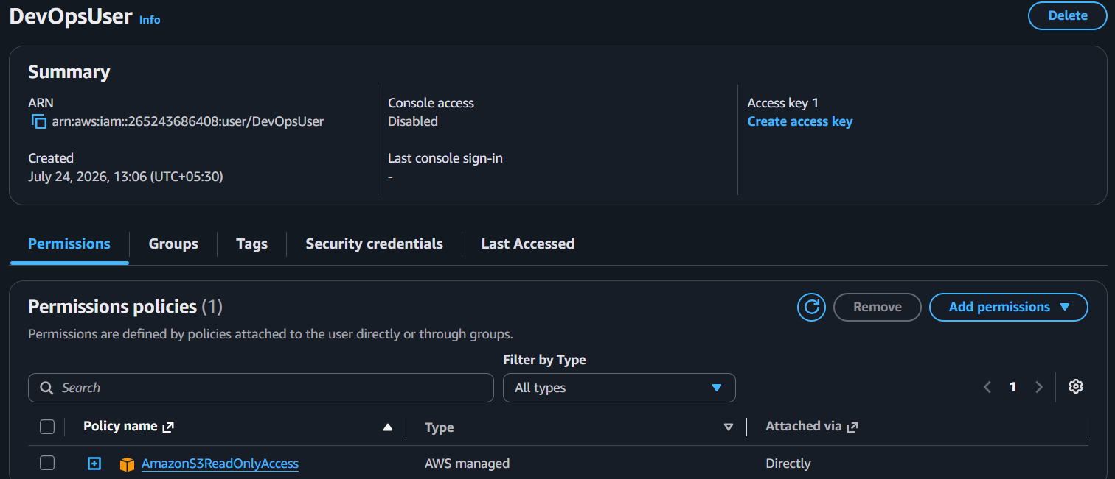

Account B (Friend's AWS Account)
Step 4: Create an S3 Bucket
Go to:
S3 → Create Bucket
Example: nikhil-demo-bucket-0549

Step 5: Upload a Test File
Upload a file such as:
hello.txt

Step 6: Add Bucket Policy
Go to:
S3 → Bucket → Permissions → Bucket Policy → Edit
- YOUR_ACCOUNT_ID → Your AWS Account ID.
Click Save Changes.

Step 7: Test from Account A
Configure the AWS CLI with the IAM user's access keys:
aws configure
List the bucket:
aws s3 ls s3://nikhil-demo-bucket-0549
Download a file:
aws s3 cp s3://nikhil-demo-bucket-0549/hello.txt .

